What It’s Like to Ride in a Real Self-Driving Car



1.

Waymo spun out of Google to create a self-driving car company. Recently, it launched a commercial service in a suburb of Phoenix: Chandler, Arizona.

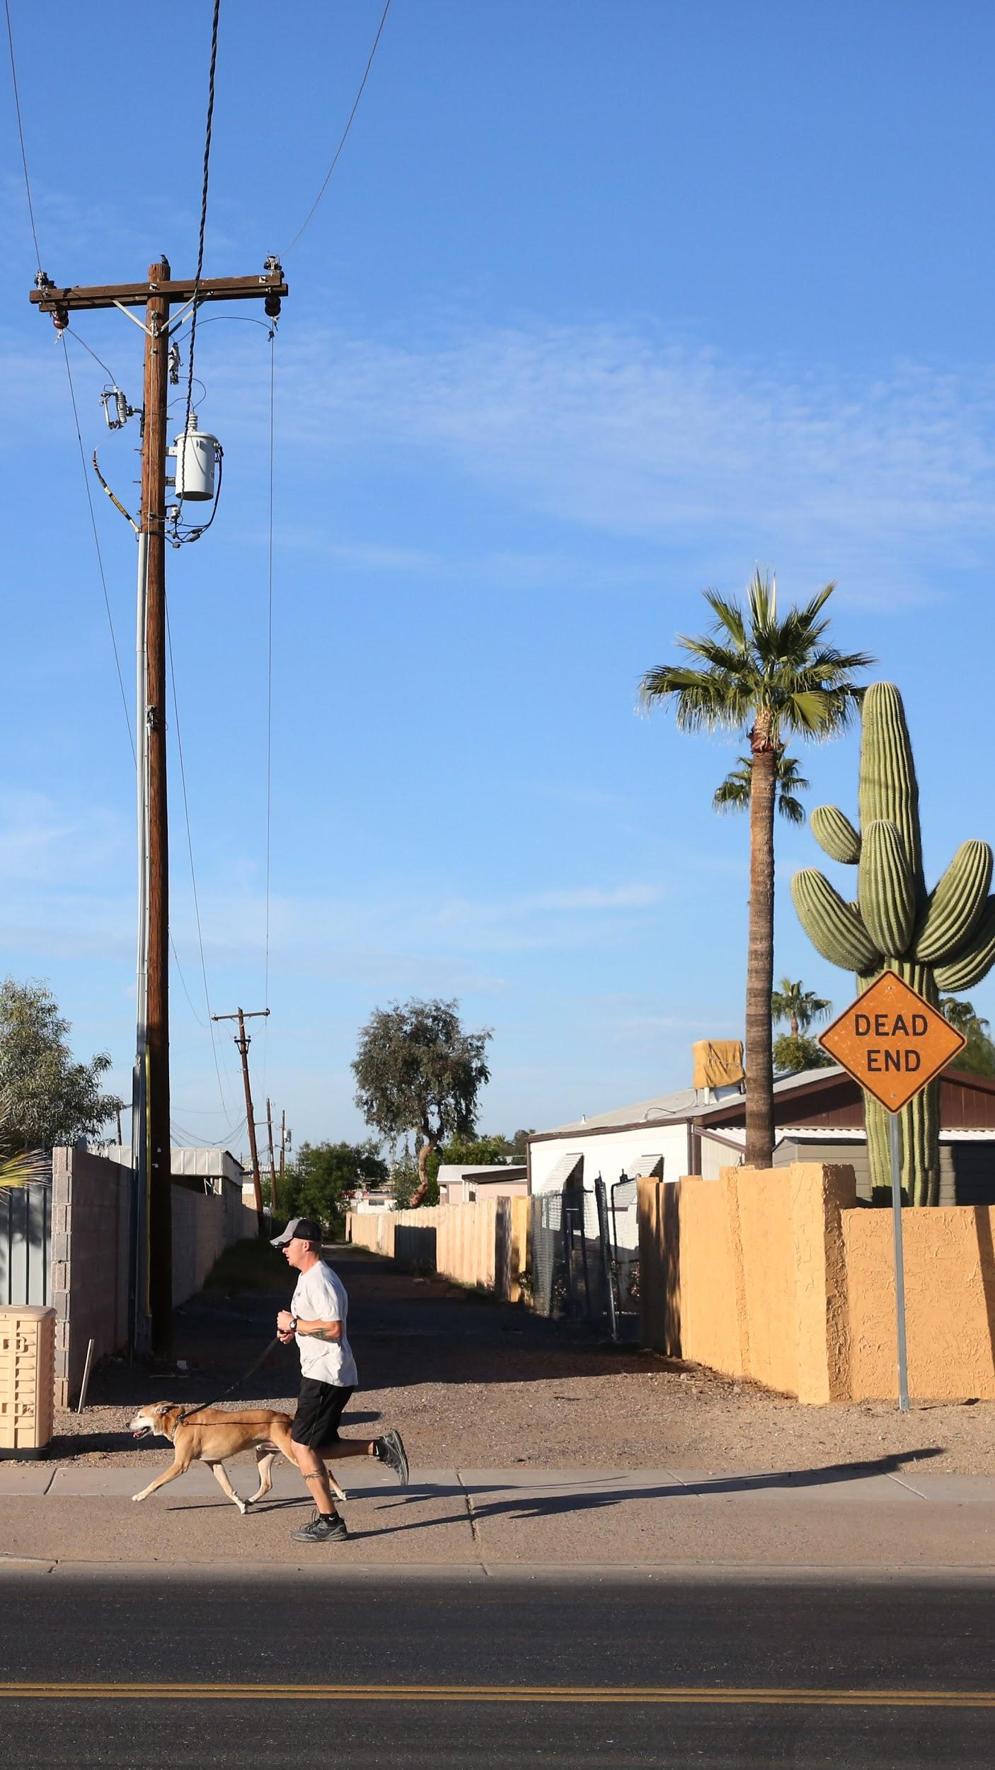

2.

I got to ride in one of Waymo’s vehicles through the streets. Here’s what it felt like.

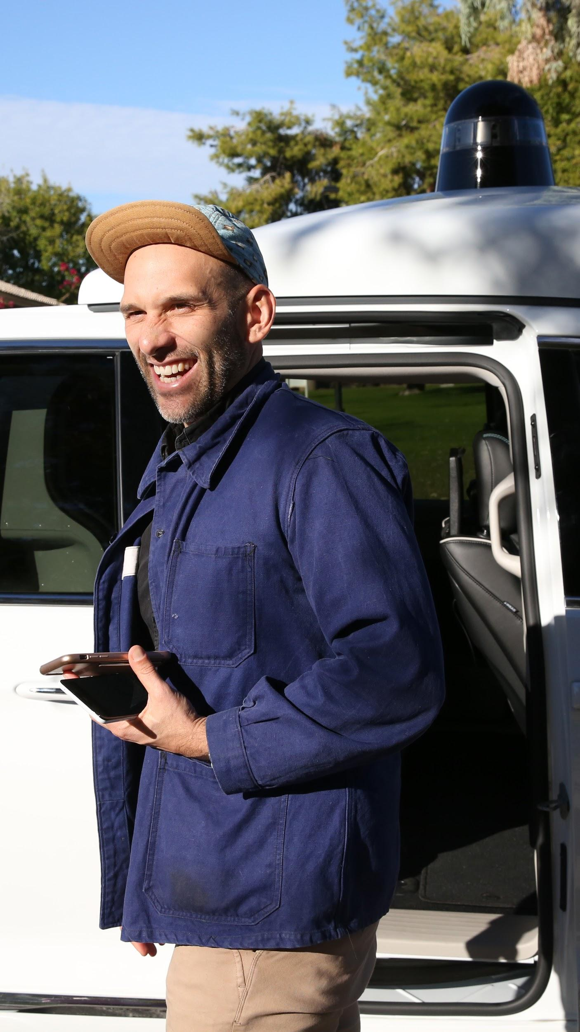

3.

You call the car like any Uber or Lyft. It shows up and you hit a big button marked START RIDE.



4.

Inside, there is a screen that shows you how the car processes the outside world. It shows the shape of the road in perfect detail, a bright little model of the minivan pursuing the line of its path through the world.

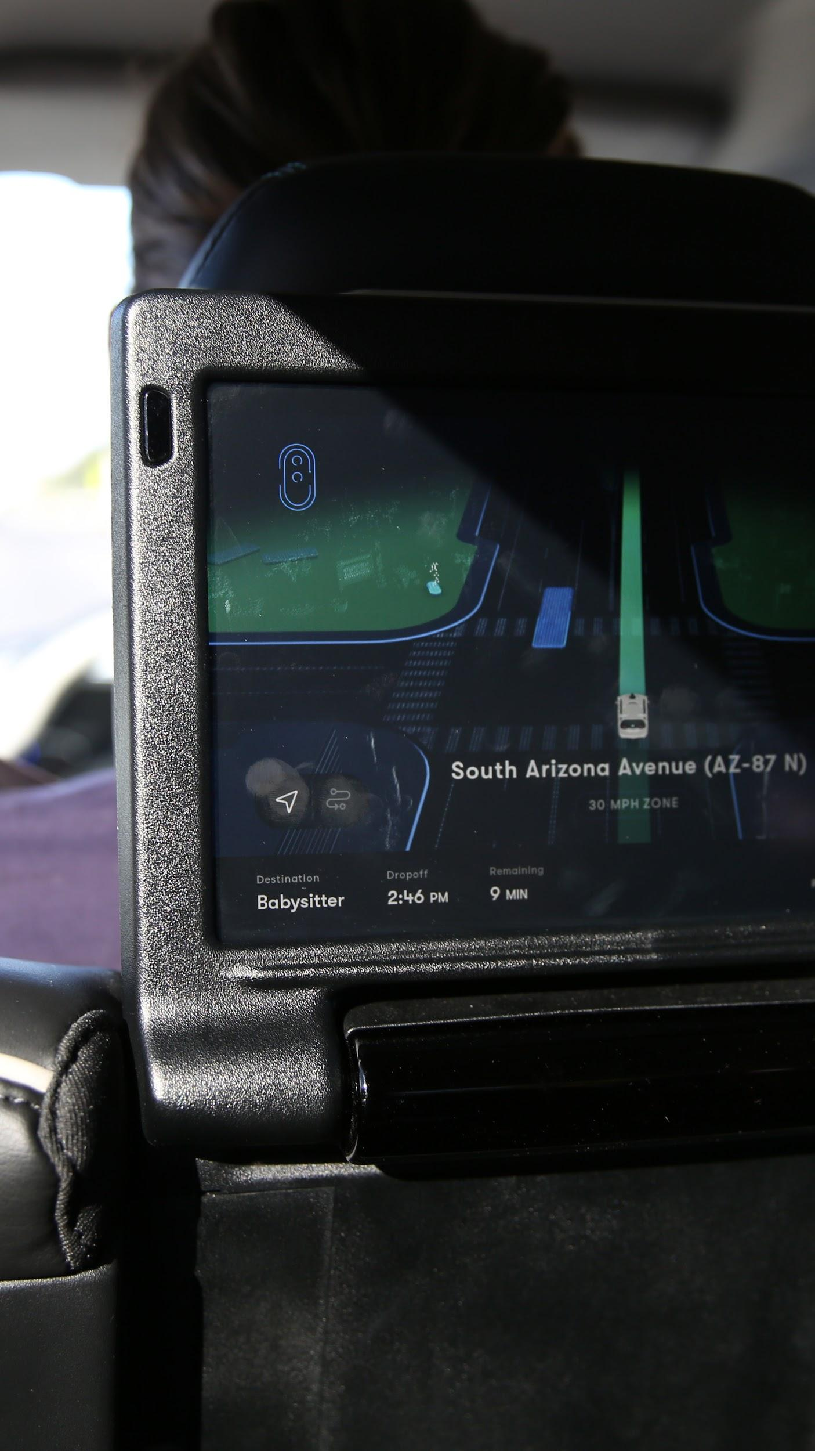

5.

The world—as seen by the car’s laser rangefinding system and cameras—shimmers in and out of existence every four seconds. People are shown as three-dimensional clouds of gray points moving atop a circle; they shimmer like a school of tiny fish.

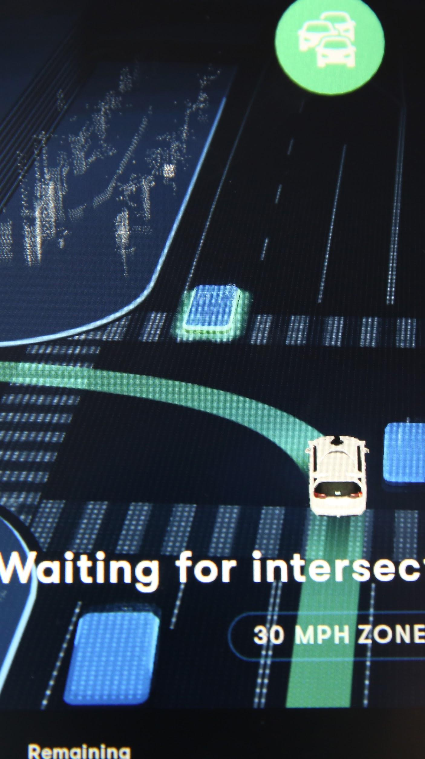

6.

In most circumstances the car drives safely, but not aggressively. Merging is hard, but merging is hard for humans, too.

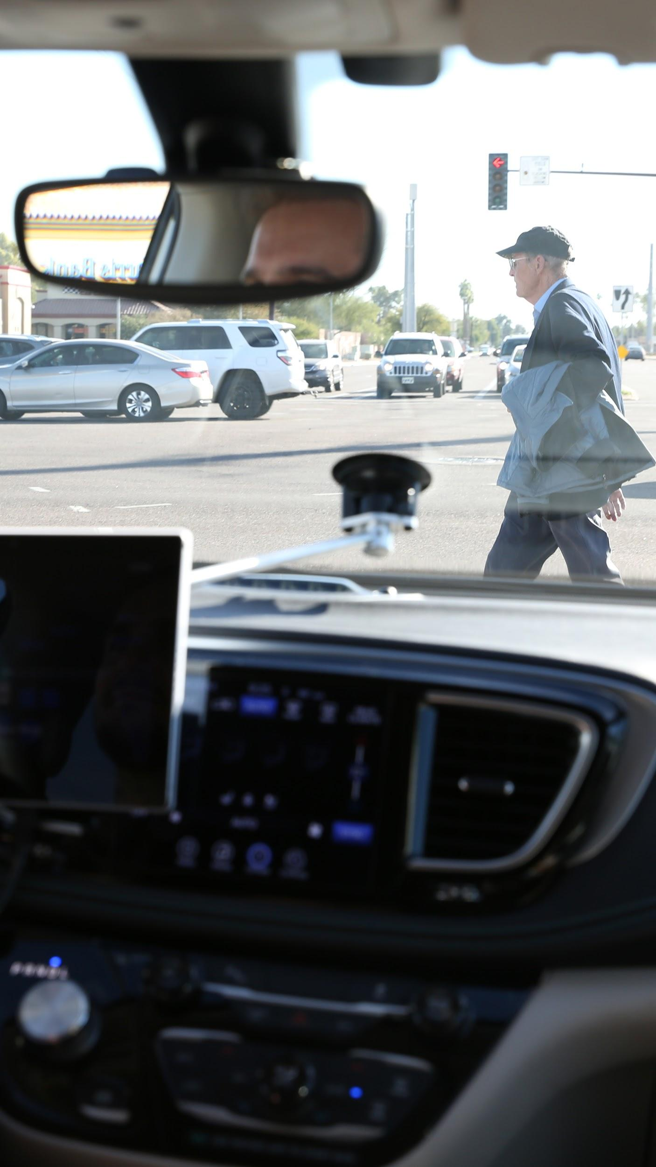

7.

Sometimes funny stuff happens. One time, the car dropped me off and I hailed it again immediately. As I stood there on the curb, the Waymo took off, slowly, headed down the street, turned around, and pulled back up to the curb.

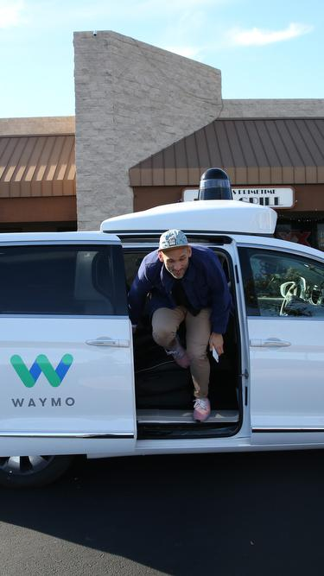

8.

Robot cars are not like humans. They don’t drive like us. They don’t know anything about the world other than the rules of the road.

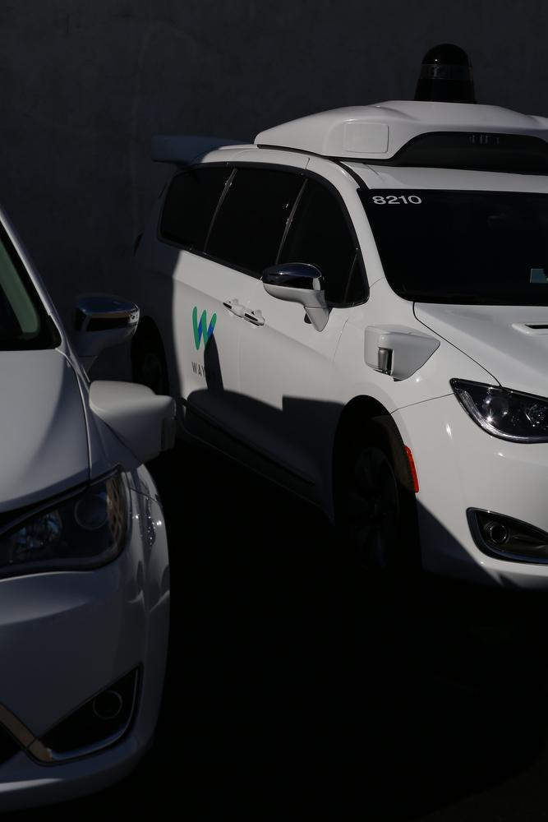

9.

The strangest thing is watching the wheel turn without a hand touching it. It’s like a ghost is driving the car.



10.

There are a lot of people—inside and outside the technology industry—who are very skeptical about the prospects for self-driving cars.

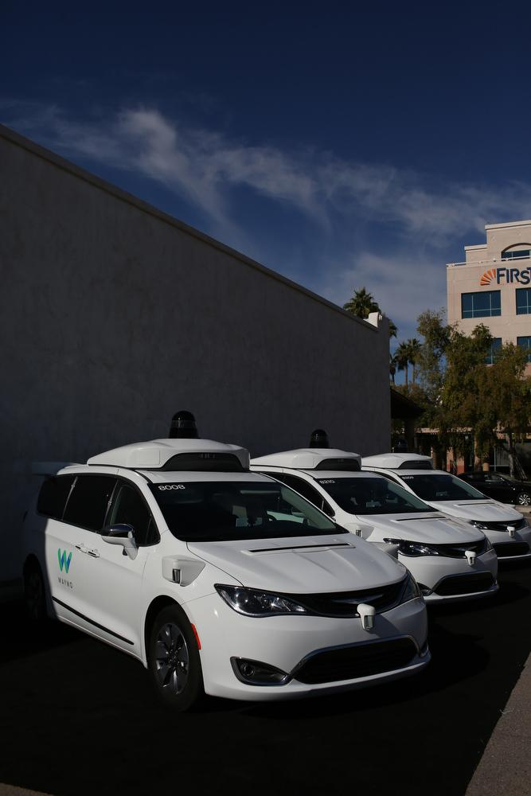

11.

Some are skeptical about the future of self-driving cars. Lots of people in Chandler have experienced the robot cars stuttering or behaving strangely, especially around parking lots, which are chaotic.



12.

Waymo is rolling out its service very slowly, but it is rolling it out. The company has ordered tens of thousands of cars for its fleet.

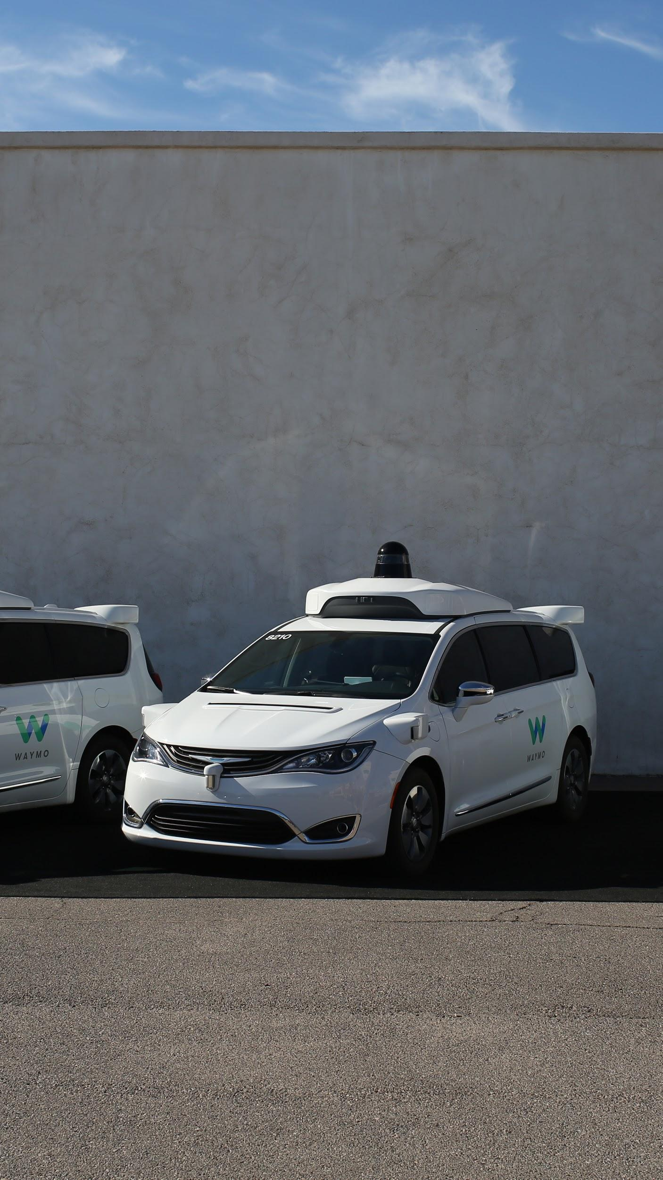

13.

By the mid-2020s, who knows what the roads will look like?

